RESERVE TOWNSHIP Fall 2018

NEWSLETTER

33 Lonsdale Street

Pittsburgh, PA 15212

412-322-1551





reser

**GARBAGE COLLECTION DELAYS**

Veterans Day Nov. 12th delayed until Sat., Nov. 17th

Thanksgiving Nov. 22nd delayed until Sat., Nov. 24th

Christmas Dec. 25th delayed until Sat., Dec. 29th

New Year’s Jan. 1st delayed until Sat., Jan. 5TH

**REPUBLIC SERVICE – 1-800-464-2120**

**OFFICE HOURS: Monday through Friday**

**8:00 AM to 4:00 PM**

**OFFICE CLOSED**

**November 12 – Veterans Day Holiday**

**November 22 & 23– Thanksgiving Holiday**

**December 24 & 25– Christmas Holiday**

**Dec 31 & Jan 1, 2019 – New Year’s**

**PLEASE NOTE: LUNCH WITH SANTA DATE CHANGE**

**SATURDAY, DECEMBER 1, 2018 – See Registration Form**

**Reserve Township has agreed to partner with AARP** to do senior citizens income taxes for FREE starting in Feb. 2019. Under a federal grant program, the IRS certified volunteer income tax assistants will provide this tax service to older Americans with low- and moderate-income filers and people with disabilities FREE. Generally, taxpayers must have an annual income below $60,000 to qualify. You DO NOT have to be an AARP member to get tax help from the IRS certified volunteers.

**This is by appointment only.**  You will not be able to just walk in and have your taxes done. Look for further details to follow in an upcoming newsletter for the number to call and the days and

times available.

**Attention Landlords, Managers and Tenants**

Reserve Township requires, **by Ordinance**, that all owners, landlords, managers and agents **MUST** register all tenants/renters from all properties located in Reserve Township. An **Occupancy Permit** is needed for new tenants and sale of property. **Tenant Registration** form is needed for every new tenant. Forms are available at the Township Office or on the website at **Reservetwp.com.**  (There is a fee of $50.00 for every occupancy permit needed). **Non-registration could result in citations**.

*****************************************************************************

**EMERGENCY ALERT SYSTEM**

**FOR RESIDENTS**

If you have not done so already, **PLEASE** sign up for our Community Alert System. To sign up open your web browser and type the following address into your address bar: <https://public.coderedweb.com/CNE/BF078B4DEF7F> or contact the Township 412-322-1551

Schools are open

**PLEASE PAY ATTENTION TO CHILDREN AND STOPPED BUSES**.



**THANK YOU!!!!!**

**TO EVERYONE THAT CAME OUT FOR THE GUNS VS HOSES SOFTBALL GAME AND TOUCH A TRUCK EVENT.**

**CONGRATULATIONS TO THE POLICE DEPARTMENT, THIS YEAR’S WINNERS!!**

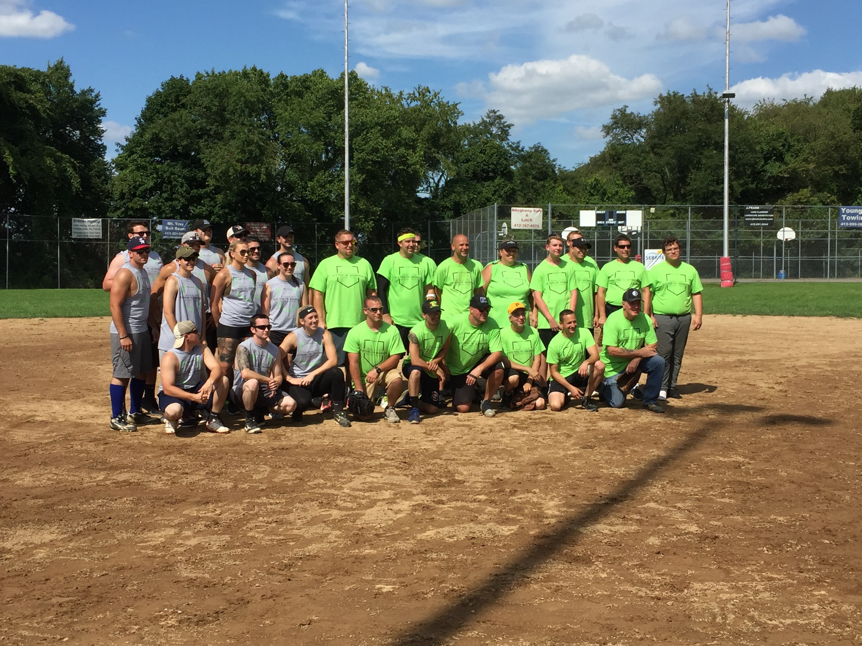

**One Live**

**Pine Tree 10’ or Larger**

**BOARD OF COMMISSIONERS**

The Board holds their regular monthly meetings on the second Monday of each month at 7:00 PM. Monthly workshop meetings are conducted on the fourth Monday of each month at 6:00 PM. All meetings are held at the Township Office, 33 Lonsdale Street.

**OFFICE HOURS**

**Monday Closed * Tuesday 9am–Noon**

**Wed. 4:00pm-8:00pm * Thursday 9am-Noon**

**Friday Closed**

**PROPERTY TAX COLLECTOR**

**JOHN ALIOTO – OFFICE # 412-322-2235**

**NOTE**: Although payments can be dropped off at the township during the Tax Collector’s off hours, receipts or tax information **Can Only Be Given by the Tax** **Collector.** Township employees are NOT permitted to handle tax bills. No receipts will be mailed back unless a self-addressed stamped envelope is provided.

**Dance Showcase**

Classes at Reserve Primary

Girls ages 3 and up Preschool, intro, tap, ballet, baton, acro, hip hop, and jazz

Boys tumbling ages 4-7

Classes begin mid-September

Open registration through October

Please contact Leanne LaSala 412-511-1187 or Laura Luksik 412-860-7764 for more information or check out our website at

[www.danceshowcasell.com](http://www.danceshowcasell.com)



If you are interested in donating a tree for Reserve Townships decorating event, please contact Lisa at the Township Office at 412-322-1551. Thank You!

  ***Served***

80’s Night

Reserve VFD Presents

Ferris Bueller’s Revenge

The Ultimate 80’s Party Band

Saturday, October 6th

Admission $25.00-Presale ONLY

Includes Dinner, Beer & Set-ups ***(BYOB)***

Doors Open @ 5:30-Dinner is @ 6:00

Dance the Night Away From 7-11

Info: 412-335-6031 or 412-352-3815

***It’s green and beautiful but it’s looking quite bare, won’t you come and help us by adding some holiday flair?***

***Saturday, December 1, 2018***

***Township of Reserve Parking Lot***

***2:30 PM***

***(Immediately following the Lunch with Santa)***

***Asking families to bring an***

***ornament to hang on the tree. (New or homemade)***

***Hot Chocolate and Cookies Served***

************ELECTION DAY************

TUESDAY, NOVEMBER 6, 2018



**Class of 1988 30 yr. Reunion**

For more information see the Shaler Class of 1988 30 yr. Reunion Facebook page or email: rebee@verizon.net



**Sunday, November 11, 2018**

**Mt. Troy Ballroom**

**1:00 PM - doors open at 11:30 AM**

**6 cards for $5.00**

**Additional cards are available for purchase**

**For more Information call Marlene @**

**412-321-9771**

RESERVE VFD

TURKEY

BINGO



TRICK OR TREAT

Wednesday, October 31, 2018

**5:30 PM to 7:30 PM**



**Join us for a tree trimming party**

**PLEASE JOIN US FOR THE HALLOWEEN PARADE**

**Sunday, OCTOBER 28, 2018**

The Annual Reserve Township Halloween Parade will be held on Sunday, October 28, 2018. The parade will begin at 1:00 PM sharp – Rain or Shine. The parade will form on the corner of Pittview Ave & Mt. Troy Rd in front of Standard Bank. Check in starts at 11:30 AM. A shuttle will be available for those who wish to park at the Township office or Reserve School.



**\* Refreshments * Raffle prizes**

**Awarded for Best Costume * Pre-registration is mandatory**

**Registration slips must be returned to township office by Monday, October 22, 2018 or email information to Kim at admin.assist@reservetwp.com**

Last Name: ___________________________________ Address:__________________________________________

Child’s Name Male/Female Age

___________________________________________________________________________________________________________________________________________________________________________________________________________________________________________________________________________________________________________________________________________________________________________________(LWS)

**LUNCH WITH SANTA** * **Saturday, December 1,2018**

Photo with Santa-Crafts-Face Painting-Letters to Santa–Food-Refreshments

Mt. Troy Ballroom 1:00 PM (Doors open at 12:30 PM)

Pre-Registration – Return form by Friday, November 23, 2018 or email information to Kim at [admin.assist@reservetwp.com](mailto:admin.assist@reservetwp.com).

**Please stay afterwards for the Tree Trimming Party**



Last Name: ___________________________________ Address: __________________________________________

Child’s Name Male/Female Age

____________________________________________________________________________________________________________________________________________________________________________________________________________________________________________________________________________________________________________________________________________________________________________________________(HP)

***************************************************************************************************